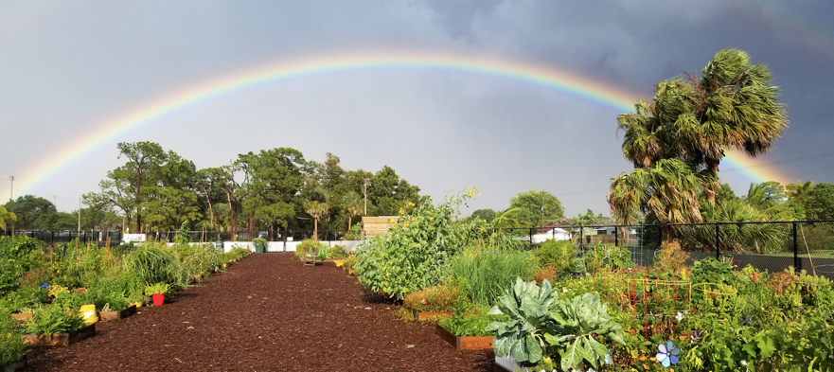
JLBR Community Garden

Visit the Boca Raton Community Garden

The Community Garden is located at Meadows Park (1300 NW 8th Street Boca Raton, FL 33486)

Garden hours: Monday to Saturday from 8:00 AM to Sunset, and Sunday from 8:00 AM to Sunset. Please remember to always keep the gates closed to keep iguanas and other wildlife out.

Contact Info: Garden@JLBR.org

Cultivating a Community

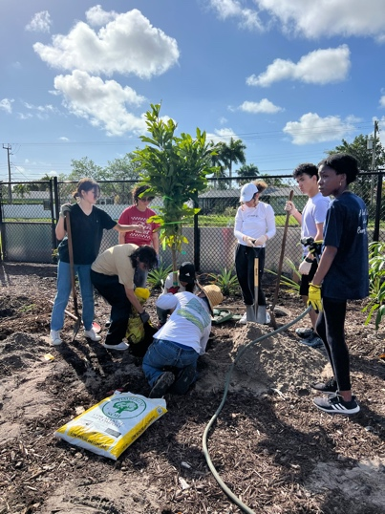
The garden fosters environmental sustainability and stewardship, advances horticultural and nutritional education, provides a beautiful and natural retreat, with therapeutic benefits, and aromatherapy, and produces a healthy supplemental food source for its gardeners and the hungry. The Junior League of Boca Raton founded the BRCG and is responsible for managing and maintaining the garden. The City of Boca Raton provides the land and water for the garden.
The JLBR Community Garden has received a sizeable donation from 2Day4Tomorrow Foundation to help fund and construct a food forest on the western side of the garden. We are happy to report that, with the help of our gardeners and GNOME FAU student volunteers, we were able to successfully plant more than 30 different fruit trees and plants. Accepting this generous donation from the 2Day4Tomorrow Foundation benefits the Junior League of Boca Raton and our Community Garden and significantly expands the positive impact we can have on our neighborhood through food donations to Boca Helping Hands, a smaller carbon footprint, greater biodiversity, educational opportunities, and more. Please take a tour through our food forest the next time you visit the Community Garden!

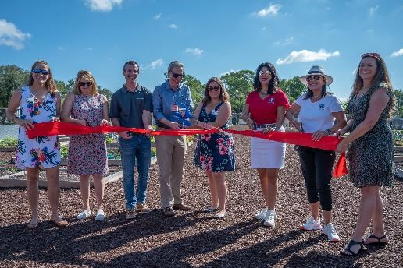
History

The Junior League of Boca Raton, Brightline, City of Boca Raton, Community Greening, and Tree City USA celebrated the grand opening of the new community garden on October 16, 2021.

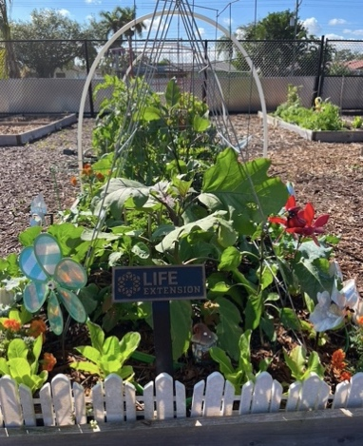
The original garden was donated by the City of Boca Raton on Earth Day 2010 by former JLBR member and Mayor Susan Whelchel. Historically, BRCG has been the largest community garden in the state of Florida.

Special Thanks
Community Garden Sponsorships:

Special Thanks to Life Extension®, Safe Sun Grant, 2Day4Tomorrow Foundation, Zimmerman Tree Service, and Hitching Post Distributing for their generous sponsorship of the community garden!
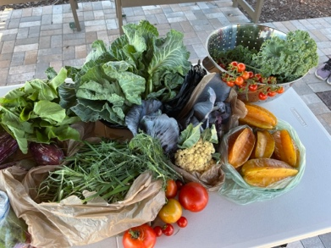

10% of all fruits and vegetables harvested by individual garden plots were donated to Boca Helping Hands. This 2022-2023 JLBR Community Garden growing season, we have already donated over 200 pounds of food through our food drive and monthly harvest days. We look forward to continuing our traditions with the new food forest which will donate 100% of its nutritious fruits and vegetables back to Boca Helping Hands.

Our Mission

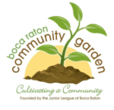
The mission of the Junior League of Boca Raton Community Garden (BRCG) is to cultivate the spirit of community and enhance the quality of life by creating and sustaining an organic garden of vegetables, flowers, butterfly plants, pollinator plants fruit tree forest, and native trees.

Support the Garden
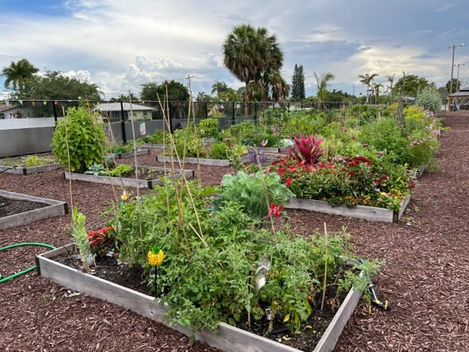
If you are interested in leasing one of the over 100 garden plots, please click here. The garden plots are posted and can be viewed on jlbr.org. Click here to review the Handbook for Gardeners.
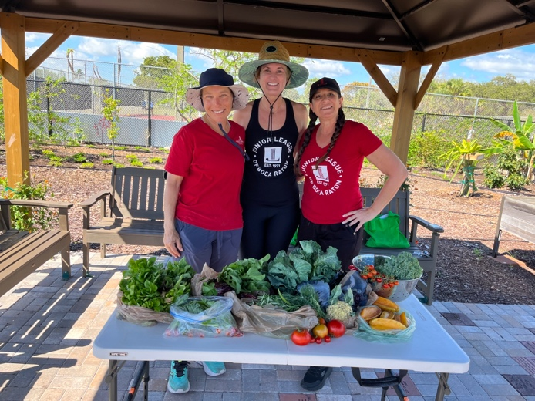
If you are interested in purchasing a brick or garden bench, please click here. These bricks and benches can be used to commemorate a loved one, promote a business, or honor a special event or person in your life.
The benches and bricks are posted and can be viewed on jlbr.org.
Click here to download the Release of All Claims and the Garden Agreement and Rules.

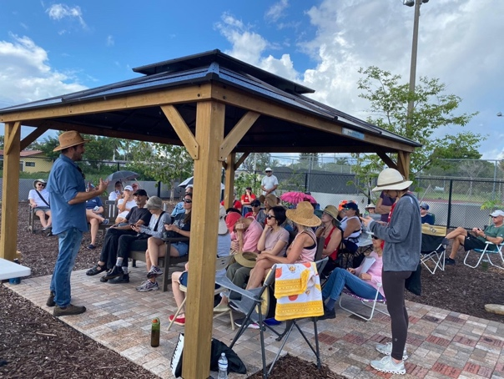
Free Garden Workshops

The Community Garden sponsors Free Garden Class Workshops for all to attend! Sign-ups are emailed to our gardeners monthly. Workshops are open to all gardeners and the general public.

Garden Gazette Official Newsletter of the Boca Raton Community Garden.(Links)
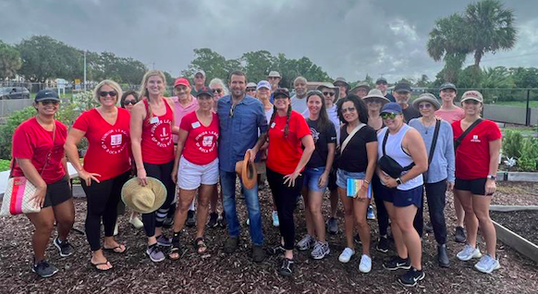
February/March 2023
December/January 2023
October/November 2022
August/September 2022
June/July 2022

