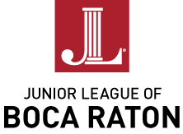
Dear Prospective Member:

There are about 260 Active members in the Junior League of Boca Raton (JLBR) and each year we actively recruit new "Provisional" members. All Provisional members are required to complete a Provisional course which acquaints potential members with the workings of the League, its membership requirements, and some of its community service programs. After successfully completing the Provisional course, a woman is invited to become an Active member.

On behalf of the Junior League of Boca Raton, we would like to extend a warm welcome to each of you considering membership in our League and in the Association of Junior Leagues International. This packet of information has been assembled to help you in your decision­ making process. Enclosed, you will find:

- Information about the application process
- General information about the Junior League
- Information about the provisional course

Please read over this information carefully.

The Junior League of Boca Raton is an organization of women committed to promoting voluntarism and to improving the community through the effective action and leadership of trained volunteers. We are excited about the Junior League of Boca Raton and its role in our community. This organization has over a 40-year legacy of commitment to voluntarism and providing high quality training and education for its membership.

We invite you to consider becoming a committed member of this dynamic organization.

Sincerely,

Margi Cross Laurie Daniels
Membership Manager Training Manager
2016-2018 2017-2019
APPLICATON PROCESS

The application process of the Junior League of Boca Raton is an informed prospective member system, which means that each prospective member has consented to her proposal and is involved in completing the Proposal and Prospective Member form.

Each prospective member should have a sincere interest in the purpose of the Junior League and the willingness to be trained to participate in its programs.

Membership in the Junior League of Boca Raton is based on the following criteria:

- Age
  - Must be at least 21 years of age by the start of the course.

- Residence
  - The member shall reside in North Broward to Southern Palm Beach County area at the time of her application for membership.
  - The JLBR shall be responsible for orienting the prospective member to the privileges and responsibilities of Junior League membership before she agrees to join.

The prospective members whose applications have met the above requirements shall be invited to Provisional membership.

- The prospective member shall have an interest in voluntarism.

- The prospective member shall possess a commitment to community service.

- The prospective member shall possess a commitment to the mission and vision of the Junior League of Boca Raton.

- The prospective member must show an interest in developing her potential for voluntary community participation.

- The prospective member shall be fully aware of the financial obligations and time commitments involved with League membership and should be capable of and willing to meet them.

JUNIOR LEAGUE OF
BOCA RATON INFORMATION

MISSION

The Junior League of Boca Raton, Inc. is an organization of women committed to promoting voluntarism, developing the potential of women and improving communities through effective action and leadership of trained volunteers. Its purpose is exclusively educational and charitable.

The Junior League of Boca Raton welcomes all women who value our Mission. We are committed to inclusive environments of diverse individuals, organizations and communities.

VISION

The Junior League of Boca Raton will provide resources, knowledge and funding to the community through the training, education and voluntarism of its members. The Junior League of Boca Raton will be proactive in developing collaborative partnerships to address significant issues in South Florida and will improve the overall quality of life through a legacy of trained volunteers.
The Junior League of Boca Raton focuses on three issue in our community: hunger, nonprofit support and child welfare.

What is the Junior League?
A nonprofit, charitable and educational organization of women interested in becoming effective volunteers in the community. Members are educated about community needs through membership meetings and committee work; they are trained in the skills for community leadership through participation in League committees, and community service programs. In these ways, members seek to fulfill their desire for personal growth while serving the community in which they live as trained volunteers committed to a better society.

What is AJLI?
The Association of Junior Leagues International. The Junior League was started in 1901 by 19-year-old Mary Harriman in New York City. She started the league as part of the Settlement Movement which was born to help blend together the different classes of people. Since its founding, The Junior League has evolved into one of the oldest, largest and most effective women’s volunteer organizations in the world, encompassing 150,000 women in 291 Leagues in four countries.

When was the Junior League of Boca Raton started and how large is it today?
In 1971, the Junior League of Boca Raton was founded. There are currently 700 active and sustaining members in our Community

How does one become a member of the Junior League?
Each Junior League has its own admissions policy; each has its own set of bylaws. All Leagues admit new members on an individual basis. Young women who have an interest in voluntarism and a commitment to community service can be invited to join a League.

Does the League have dues?
Each League sets its own dues structure based mainly on the degree of maintenance and administrative services required. JLBR dues are $167.00 for Actives and Provisionals and $132 for Sustainers, of which $43 is sent to AJLI. There is an additional $50 (non-refundable) Provisional course fee which covers all necessary materials. Monies raised in the community are returned to the community for projects which fill community needs. The League may not raise money for other groups.

- Can one transfer membership from one League to another?
- Members of Junior Leagues may transfer from one League to another with all the privileges of their class of membership; i.e., Provisional members transfer as Provisionals, Active members as Actives, and Sustaining members as Sustainers.

- How long does a member stay in the Junior League?
A Junior League member may continue her active membership indefinitely or until she is eligible to become a Sustainer. At present in the Junior League of Boca Raton, after a member reaches the age of 40 and has served 5 years of active membership or has served 10 years (excluding her provisional year) if under the age of 40, she may become a Sustainer. This means she continues to apply her League education and training to old and new areas of community need, but without the obligations which the League requires of its Active members.

JUNIOR LEAGUE OF BOCA RATON - STRUCTURE AND TERMS

Board of Directors
President
President-Elect
Managing Director
Director of Nominating
Director of Finance
Board Member At Large
Board Member At Large
Board Member At Large (Sustainer)
Presidential Administrator

Management Team
Managing Director
Membership Manager
Training Manager
Community Issues Manager
Finance Manager
Fundraising and Events Manager
IT Manager
Management Team Administrator

PROVISIONAL MEMBER OBJECTIVES

1. To be motivated to become an active, effective member of the Junior League of Boca Raton.

  - To learn about the Junior League of Boca Raton--its history, purpose, activities, responsibilities of members.

  - To learn about the Association of Junior Leagues International and its relationship to the Junior League of Boca Raton.

  - To have a clear understanding of the infrastructure of the Junior League of Boca Raton.

5. To have a clear understanding of and to participate in Junior League of Boca Raton fundraising efforts.

- To understand the League's role in the community.

- To have a clear understanding of voluntarism--its importance and impact on the community.

- To demonstrate the ability to perform responsibly in volunteer community service.

- To develop camaraderie and a feeling of cohesiveness among Junior League of Boca Raton Provisional class members.

- To become Active members with a desired and suitable first-year placement at the end of the Junior League of Boca Raton Provisional course.

OBLIGATIONS

The Junior League of Boca Raton uses a points structure for completion of your obligations. Below is the list of obligations based on your membership status. On the following page you will see a chart with the menu of options available to you to complete these obligations.

In addition to their annual dues, members are required to complete the points listed below for each area based on their membership status.

Promoting Volunteerism
Active 12
Associate Active 12
TES ......................................N/A
Provisional – Fall Class 12
Provisional – Spring Class 8
Developing the Potential of Women
Active 12
Associate Active 4
TES 3
Provisional – Fall Class 12
Provisional – Spring Class 8
Transfers 6
Improving the Community
Active 12
Associate Active 6
TES 4
Provisional – Fall Class 12
Provisional – Spring Class 6
Transfers 10
Financial Commitments
Active 10
Associate Active 10
TES 5
Provisional – Fall Class 10
Provisional – Spring Class 10

Dues

Active $167
Associate Active $167
Non Resident Active $167
TES $167
Sabbatical $167
Sustainer $132
Sustainer IL $58

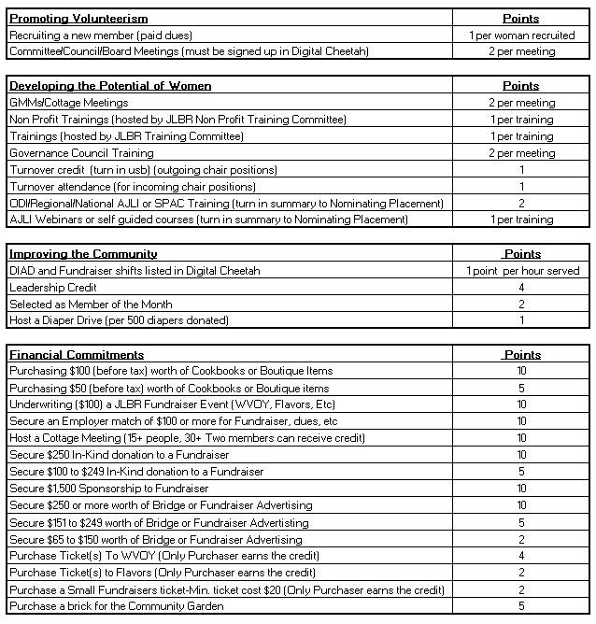

Provisional 2017 Fall Schedule

Tuesday, August 15 6:30 pm Provisional Membership Meeting
Tuesday, September 12 6:00 pm General Membership Meeting (GMM)
Saturday, September 23 8:30 am -1:30pm Super Saturday
Wednesday, September 28 TBD Social TBD
Tuesday, October 10 9am,12pm,7pm Cottage Meeting
Tuesday, October 17 6:30 pm Provisional Membership Meeting (PMM)
Monday, October 23 TBD Social TBD
Tuesday, November 14 6:00 pm General Membership Meeting (GMM)
Tuesday, November 28 6:30 pm Provisional Membership Meeting (PMM)
Wednesday December 6 TBD Social TBD

